Project Interim Report

On

Scientif calculator

(Using overloading & exceptional handling Concepts)
RU-100-01-00012
Object Oriented Programming with Java

SESSION: 2025-26

Submitted By PRINCE KUMAR Reg No.RU-25- 11016

Bachelor of Technology in Computer Science & Engineering with DS in association with GOOGLE

Under the Guidance of Mr. Ashish Shivare

SCHOOL OF COMPUTER SCIENCE AND ENGINEERING RUNGTA INTERNATIONAL SKILLS UNIVERSITY
BHILAI, CG

Abstract
The Scientific Calculator Professional project is developed using Object-Oriented Programming (OOP) concepts in Java. It is designed to perform basic arithmetic operations such as addition, subtraction, multiplication, and division, while also demonstrating advanced features like method overloading and exception handling. The need for this project arises from the importance of building robust applications that can handle multiple data types and runtime errors gracefully. By implementing method overloading, the calculator can process both integer and floating-point inputs seamlessly. Exception handling ensures that errors such as division by zero are managed without crashing the program, providing user-friendly error messages instead. The system can be extended to include scientific functions like square root, power, and trigonometric calculations. This project not only strengthens programming skills but also emphasizes the importance of designing flexible, error-free, and user-friendly applications.

Introduction
The Scientific Calculator Professional project focuses on applying OOP concepts to create a reliable and versatile calculator. Unlike traditional calculators, this system is designed to handle multiple data types through method overloading and prevent runtime crashes using exception handling. Features include:
- Arithmetic operations (addition, subtraction, multiplication, division).
- Method overloading for handling integers and doubles.
- Exception handling for division by zero.
- Optional scientific functions (square root, power, trigonometric functions).

Objectives
- Perform basic arithmetic operations.
- Handle multiple data types using method overloading.
- Prevent runtime crashes with exception handling.
- Provide user-friendly error messages.
- Demonstrate practical OOP concepts.

Scope
This project is suitable for students learning OOP concepts and can be extended with advanced scientific functions or database integration for storing calculation history.

System Requirements
- Hardware: Computer with minimum 4GB RAM.
- Software: Java JDK, IDE (Eclipse/VS Code/Edit Plus).

Methodology
• Create a Calculator class containing arithmetic methods.
• Implement method overloading for operations with integers and doubles.
• Add division methods with exception handling for division by zero.
• Extend functionality with scientific operations.
• Test overloaded methods with different inputs.
• Display results and error messages.

Flowchart
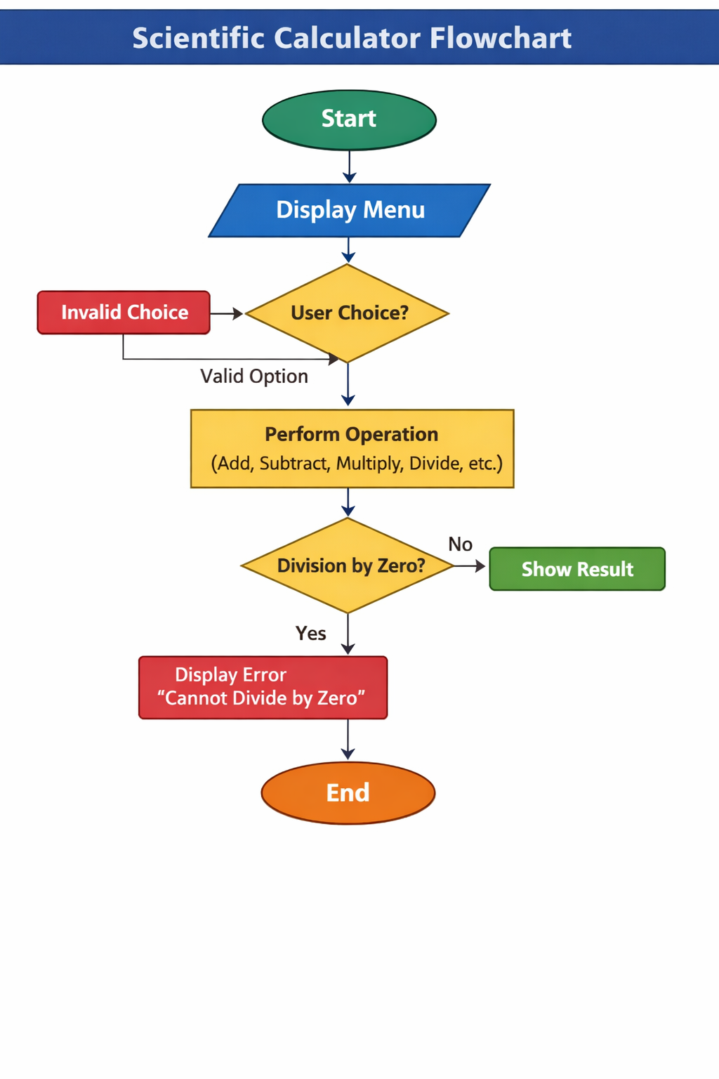
Class: Calculator
- Variables: none (methods are stateless).
- Methods:
  - add(int a, int b)
  - add(double a, double b)
  - subtract(...)
  - multiply(...)
  - divide(...) with exception handling

Implementation
- Calculator Class: Contains all arithmetic methods with overloading.
- Main Class: Creates objects of Calculator and calls methods.
- Exception Handling: Ensures division by zero is caught and handled.

Sample Input/Output
Code
Addition (int): 15
Addition (double): 7.8
Division: 5

Error: Cannot divide by zero
Future Enhancements
- Add advanced scientific functions (logarithm, exponential, trigonometry).
- Integrate GUI for better user interaction.
- Store calculation history using database.

Gantt Chart
• Planning & Structure: 2 days
• Design (Class Diagram, Flowchart): 3 days
• Coding (Calculator Class, Main Class): 5 days
• Testing & Debugging: 3 days
• Report & Presentation: 2 days

Conclusion

The project successfully demonstrates Java OOP concepts such as method overloading and exception handling. It provides a functional scientific calculator that is robust, flexible, and user-friendly, serving as a practical learning tool for student
References
[1] H. Schildt, Java: The Complete Reference, 11th ed. New York: McGraw-Hill, 2018. [2] A. Sharma and R. Gupta, "Object-Oriented Programming in Java," International Journal of Computer Science, vol. 5, no. 2, 2021. [3] Oracle, "Java Documentation," Oracle. [Online]. Available: https://docs.oracle.com

